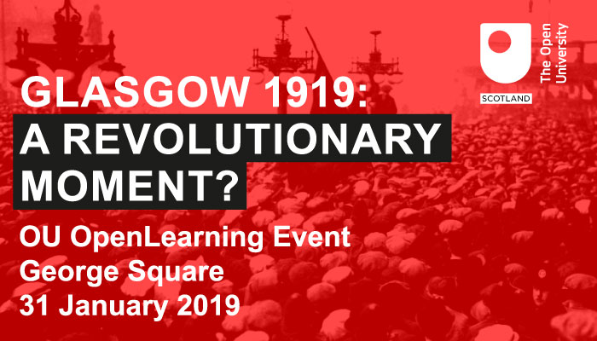

**Glasgow 1919 Centenary Open Learning Event**

***The Battle of George Square:***

***Myths, Realities and Enduring Legacies***

**George Square, Glasgow**

**31 January 2019: 12noon – 13.30**

***Glasgow 1919: A Revolt on the Clyde***

This open learning event takes place exactly 100 years to the day when the infamous Battle of George Square took place.

Widely seen as one of the key events in the period often referred to as *Red Clydeside*, much has been written about what occurred that day, but it is not unusual for such a momentous event to give rise to a wide range of different interpretations, representations and viewpoints.

Therefore, in revisiting George Square 1919, how do we distinguish the reality of what took place that day from the many myths that have surrounded the stories and narratives that have been generated in the period since?

Further, before and since 1919, George Square has been a site of protests covering a vast and diverse range of causes and issues. What is the legacy of 1919 for protests that have taken place since then and how relevant are the struggles in 1919 around the length of the working week for our understanding of protests in Glasgow and elsewhere in Scotland and the UK today?

These and other issues will be raised by our speakers and contributors in this informal learning event hosted by The Open University in Scotland. In due course the speeches from this event will be available on The Open University’s *OpenLearn* website together with other interviews and learning materials. This is open to all and can be found at [www.open.edu/openlearn/](http://www.open.edu/openlearn/)

**It is our intention to film this event for Open University learning purposes. If you do not wish to be filmed, please us know on the day.**

**If you plan to Tweet about this event, please include @OUScotland, @OU_FASS and @gerrymooney60.**



**Speakers and Contributors**

* **Gerry Mooney, The Open University in Scotland (*Introduction*)**
* **Councillor David McDonald, Depute Leader, Glasgow City Council (*Welcome*)**
* **Irene O’Brien, Senior Archivist, The Mitchell Library, Glasgow**
* **Lyn-Marie O’Hara, Glasgow City Council UNISON Shop Steward**
* **Dave Sherry, Author and Political Activist**
* **Jonzip McNeil, Musician and Songwriter (*Who will perform a song about 1919*)**
* **Jennifer Carey, UNISON Scotland**
* **Mags McCarthy, Open University Tutor, UNISON Divisional Convenor and former Labour Parliamentary Candidate**

